Problem 1

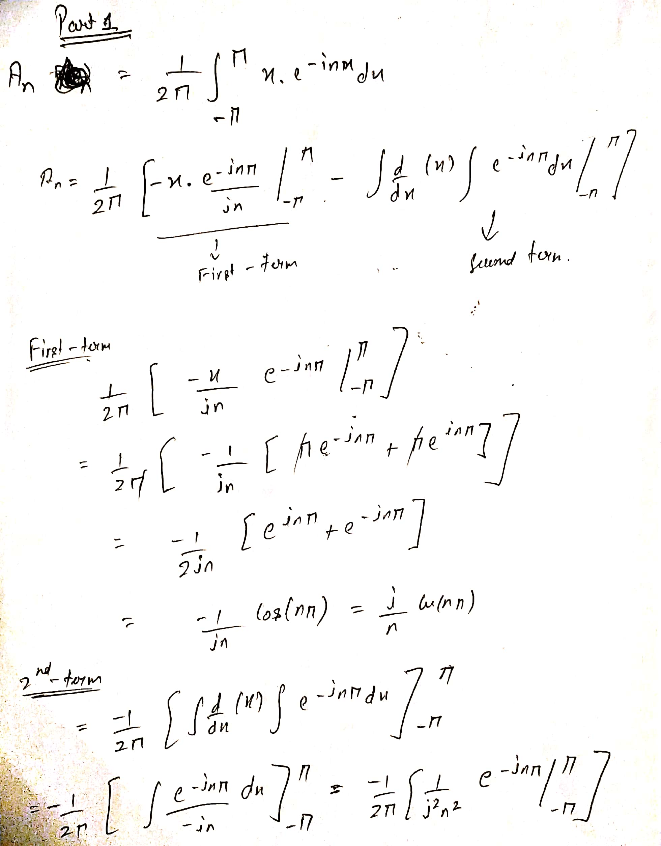

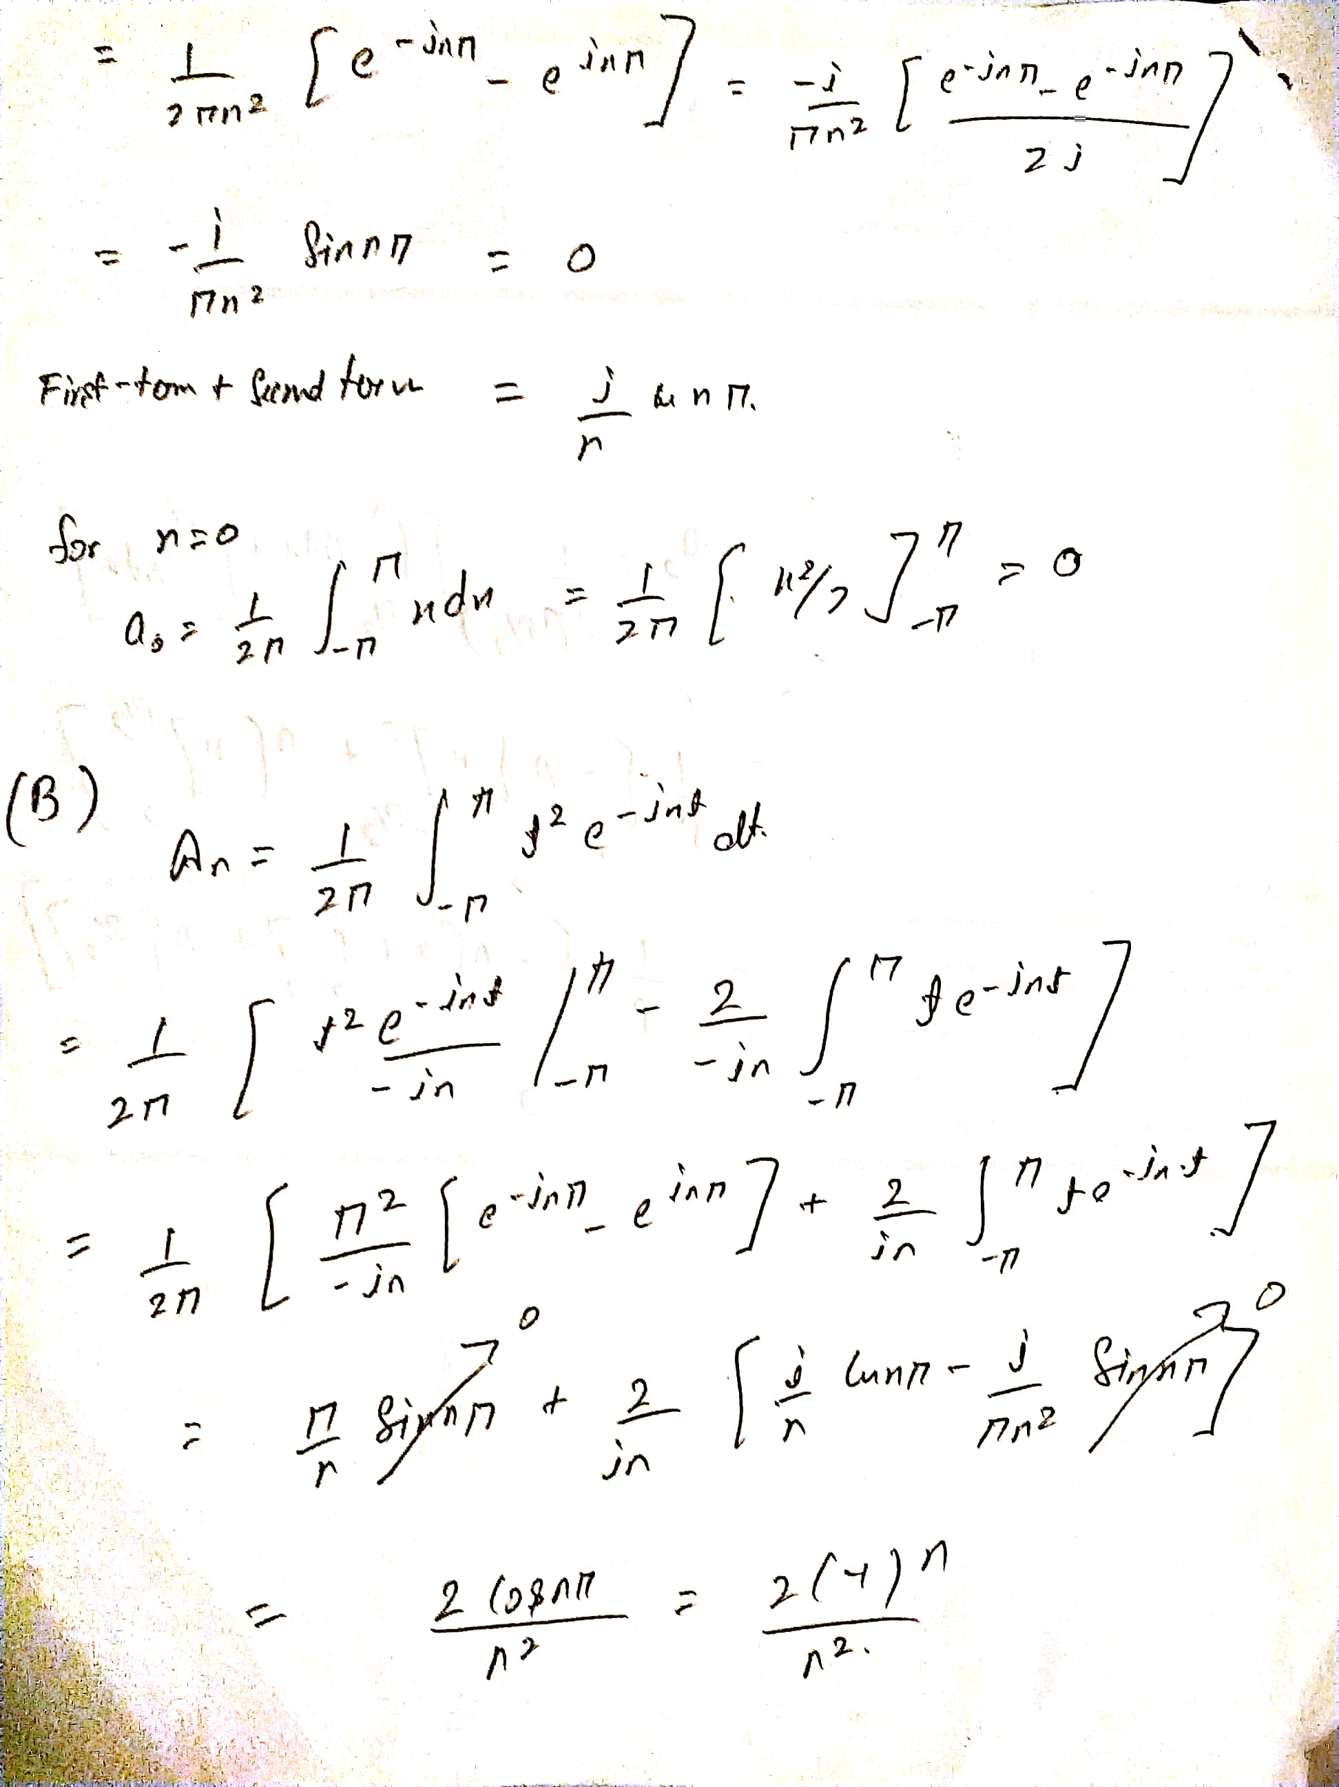

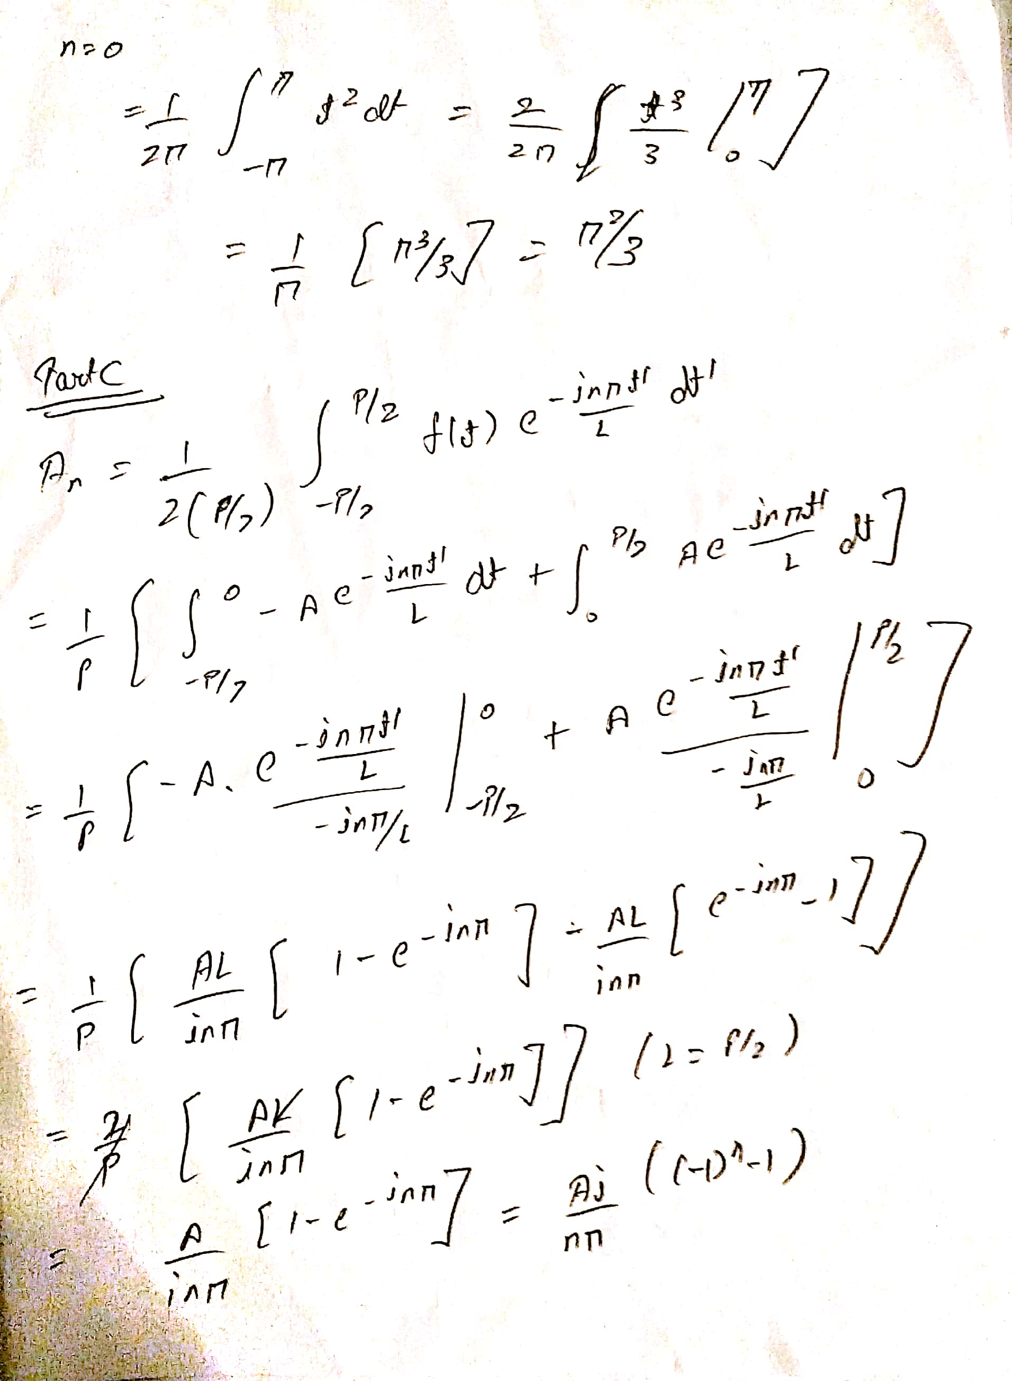

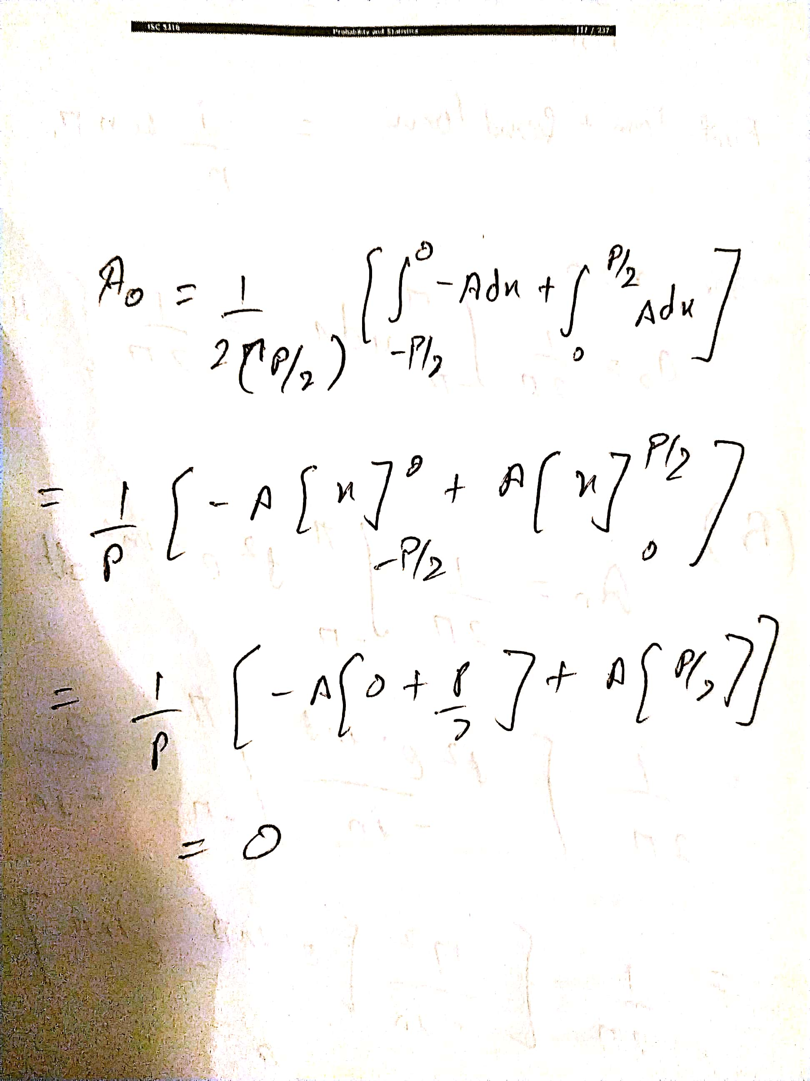

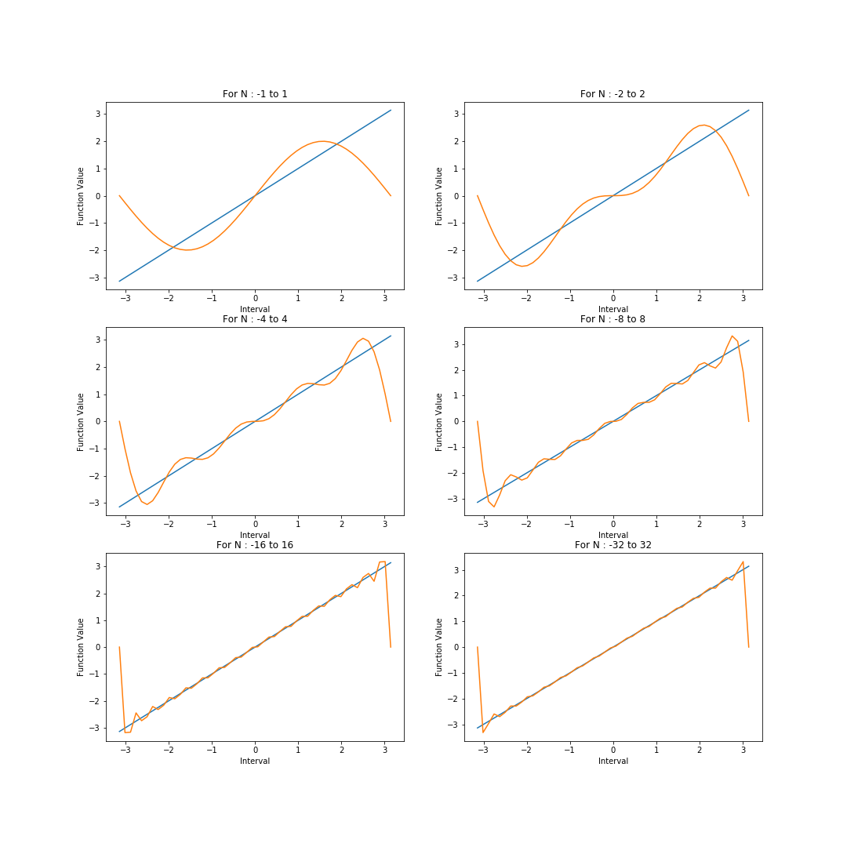

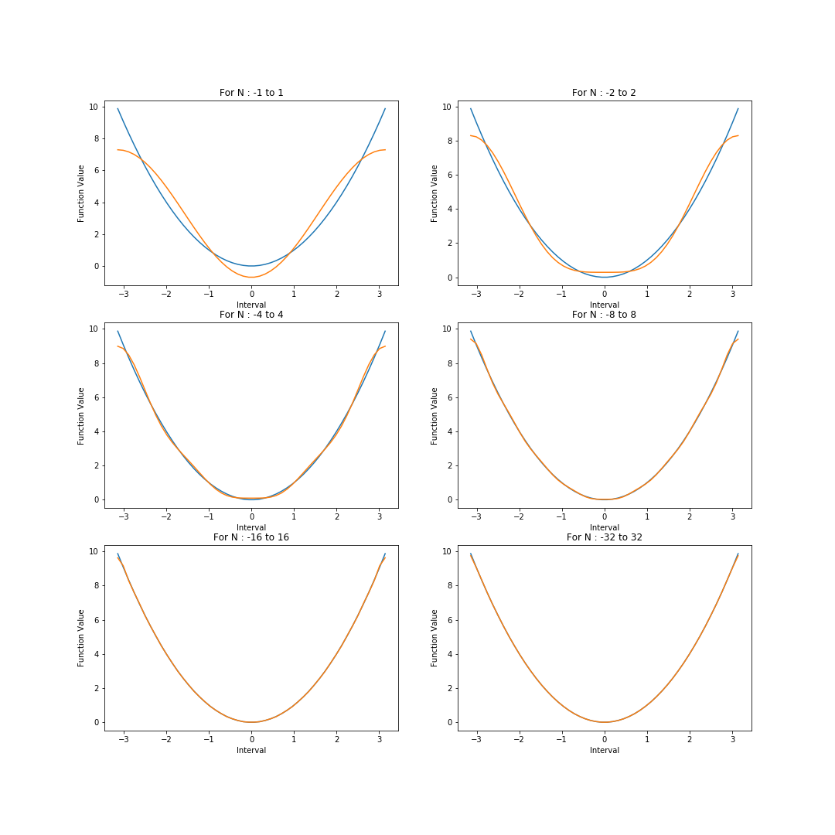

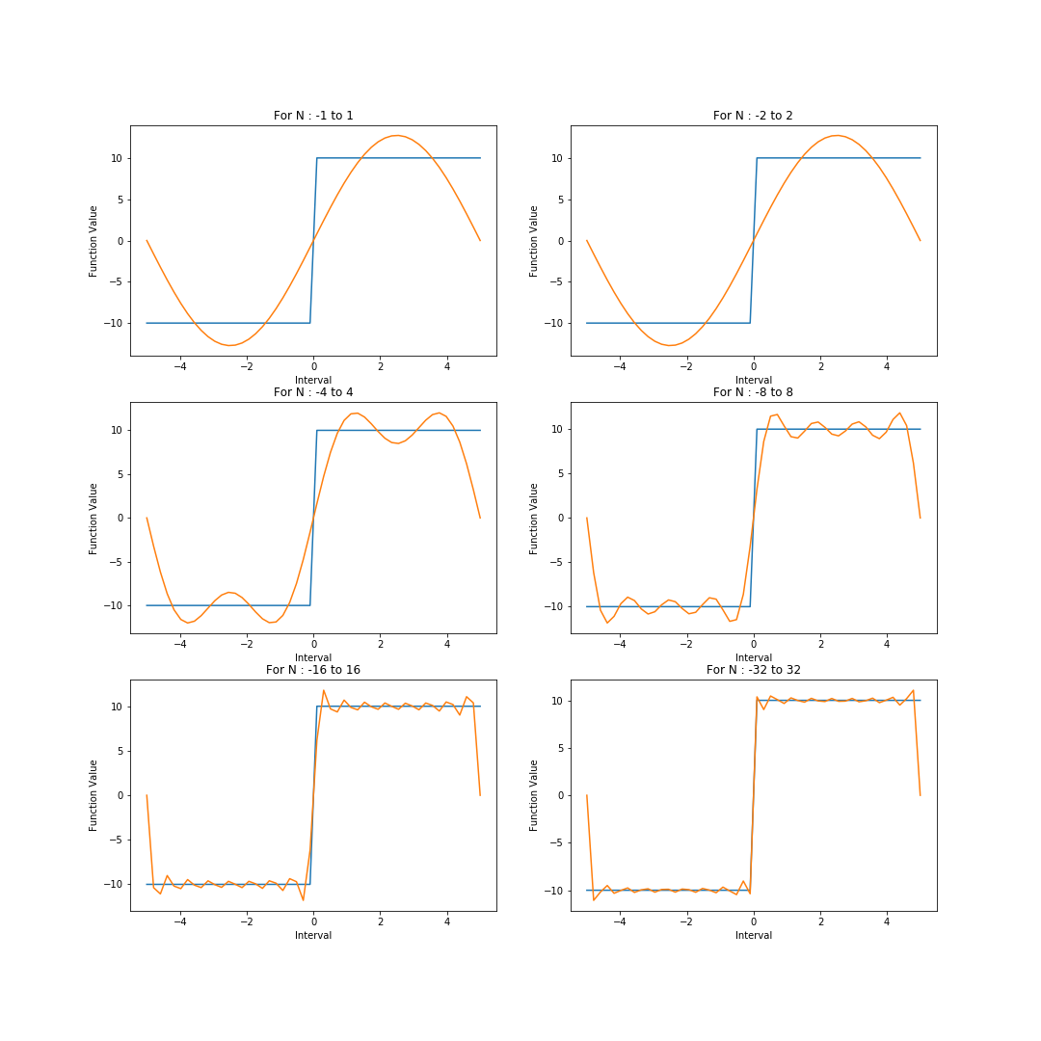

For all the three cases, we observe as the number of modes increase (n), the Fourier series become more like true analytical form. Hence the error decrease as we increase the number of Modes.

Problem 2

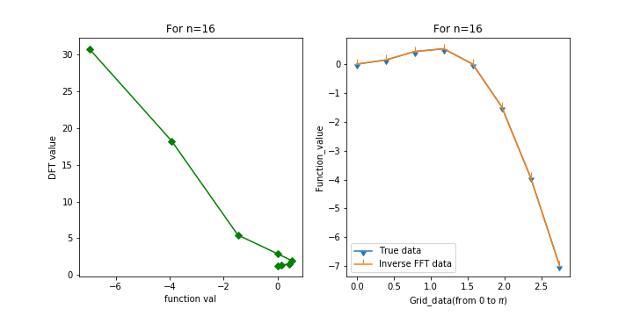

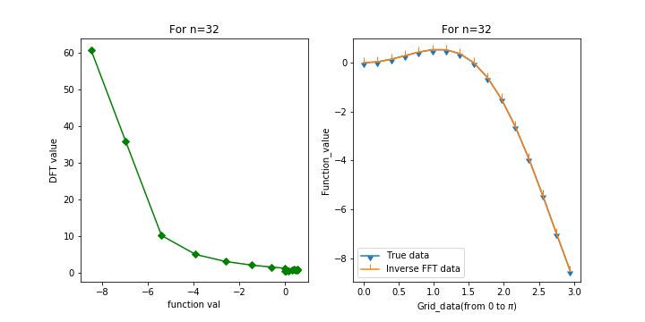

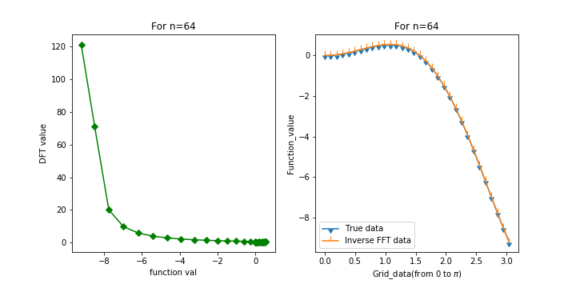

As N increase, The DFT value curve become more define though hard to interrupt because of the lack of intuition that DFT value provides in relation to N, But the Inverse Transformation of these DFT value shows that DFT value are calculated right as their inverse transformation matches with the true analytical values. As n, increase the error decrease.

Note:- I m plotting the values of data from [0,N] as [-N,0) is the mirror images of [0,N]. The FFTW pack also take indices from [0,N].

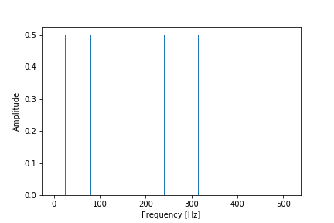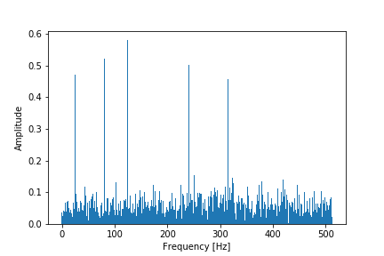

Without Noise with Noise

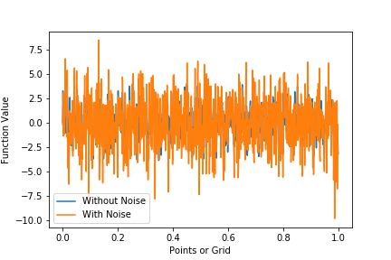

Function value with and without Noise.

The frequency spectrum of data without noise shows that signal is made up of dominating frequency at 25,80,240,315 Hz. After adding the white noise, I observe the same peak frequency. As noise is added, a lot of peak is observe in frequency spectrum as expected. However, I am not observing the peak at 125 and I am not sure why. In the function value spectrum the noisy data completely overlap on function value from clean data.

Note:- To compile the code I used the command

g++ main.cpp -lfftw3 && ./a.out